EdUHK Corpus-based ELT Lesson Design Competition
Lesson Topic/Title: Reporting Verbs in Academic Writing

Competition No. | CH 9
Author | Bin Liu
Affiliation | School of Foreign Languages, Southeast University, Nanjing China
Target Students | Young Adults/Upper Intermediate (Sophomore and above)
Corpus Used | COCA https://www.english-corpora.org/coca/
Lesson Duration | 90-135 minutes (2-3 class sessions)
Learning Objectives:
- To help students differentiate and use different types of reporting verbs in academic writing with corpus use;
- To provide students with authentic language use opportunities

Before-class Prep
Before class, ask the students to address the following preview tasks.
- Read a 2-page handout about the basics of reporting verbs.
- Browse through a short introduction to the corpus in question, COCA.
- Find a research article of their interest, identify (or highlight) all the reporting verbs in it, and bring one copy to class for classroom activities.

Warmer/Introduction
Brainstorming – Write the words ‘argue’, ‘propose’, and ‘report’ on the black/whiteboard. Put students into pairs or groups and ask them to think of other verbs that can be used for reporting, without referring to any learning material. Give students a few minutes (3 mins) to work together and write down as many as they can. Then invite one representative from each group to read aloud their findings, while other groups listen and cross out the verbs they also listed. In the end, the group with the greatest number of ‘distinctive’ reporting verbs is the winner.

Task 1: Match the reporting verbs with their definitions
Hand out a copy of Worksheet 1 to each student. Encourage them to work in pairs and match the words to the definitions. Ask them to match as many as they can without using their dictionaries, explaining that the answers will be given to them shortly.
Class feedback: check that the students have matched them correctly. Further examples and explanations could be given at this stage, to clear up any confusion that the students are experiencing.
Task 2: Gap-fill Exercise
Distribute the copies of Worksheet 2 (the gap-fill sentences) and have students complete the exercise in pairs. Class feedback: check the students have completed the gap-fill exercise completely.
Task 3: Check the concordances lines in COCA to verify the answers in Task 2
As a scaffolding activity, the instructor shows students the steps to generate inside COCA the concordance lines for the first reporting verb “hypothesize” in the box. Then students make the queries for the remaining reporting verbs.
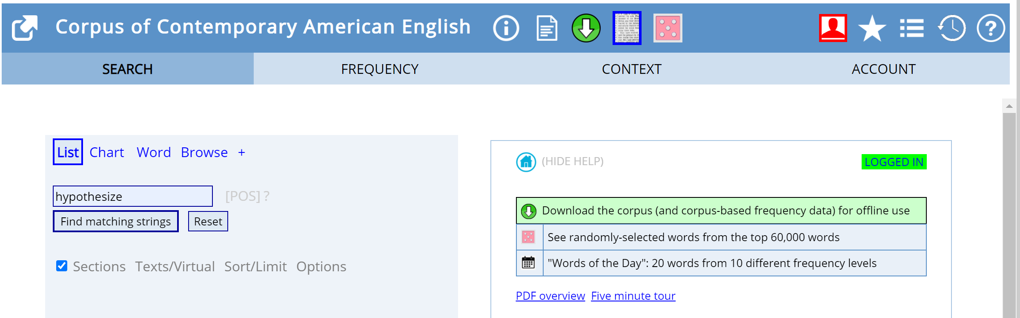
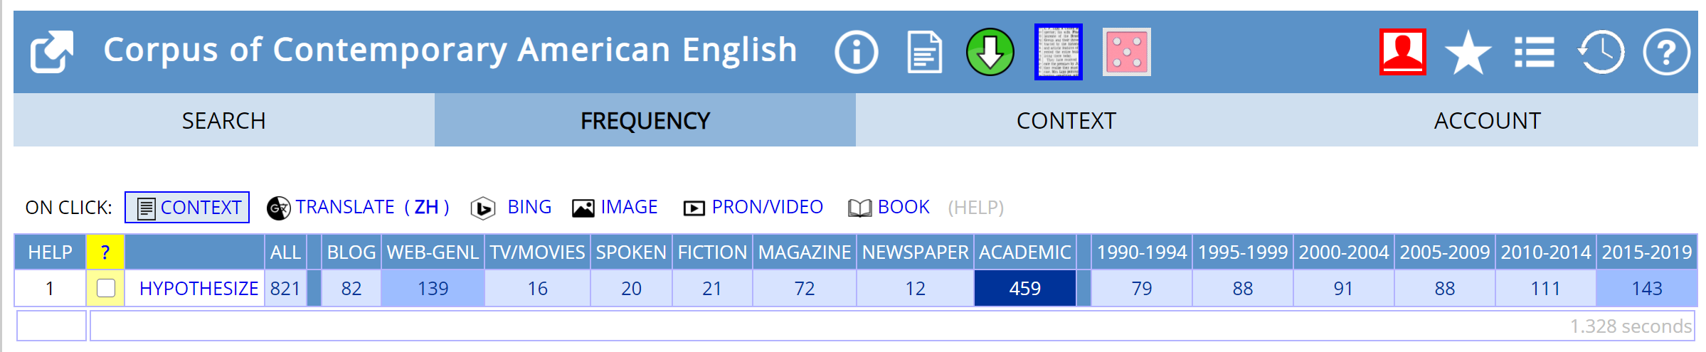
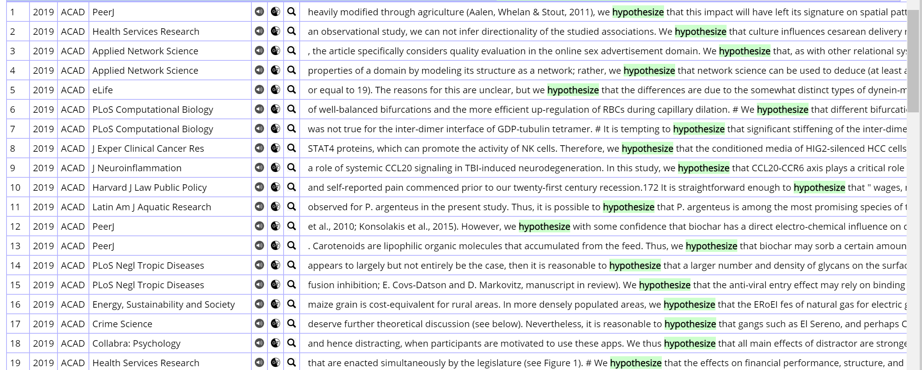
Task 4: Group discussion
Which of the reporting verbs we practised with above were more commonly used in academic writing? Have students discuss in small groups based on the research article of their choice and report back to the whole class their findings.

Task 5: Check COCA to verify the answers in Task 4.
The instructor can advise the students to follow similar steps in Task 3 to generate the frequency list for each reporting verbs they assume are more commonly used.

Task 6: Function and strength of reporting verbs
(In order not to get overwhelmed by so many reporting verbs, it is better to further classify them.) The instructor first reminds the students that there are generally three types of reporting verbs in terms of strength, weak, neutral, and strong. And reporting verbs serve different functions in different contexts. Then student groups to try to illustrate the function and strength of reporting verbs with the assistance of corpus tools. After completing Worksheet 3, groups can feedback to each other, explaining the examples they have found from the corpus. The first example of each type has been done for students.
Task 7: Small discussion in pairs
It is noteworthy that reporting verbs should not be overused. Which section in a research paper can reporting verbs be most commonly found? How many reporting verbs can be found in a certain section? Each pair report back to the class about their findings.

Task 8: Watch a short (2-min) introductory video on literature review

Task 9: (In-class pair discussion & After-class assignment) Writing
In pairs or groups complete literature review worksheet (Worksheet 4), thus scaffolding the writing of a literature review. Then each student writes a short literature review (250-350 words) based on 3-5 articles of his or her choice, using at least five reporting verbs. Verify the appropriateness of reporting verb usage with the corpora searches. The student is expected to discuss with his/her learning partner and each pair review each other’s work before submitting the final draft to the instructor. The students are encouraged to consult corpus tools and submitted repeatedly to pigai.org for instant proofreading feedback in the process of writing.
Instructor Tips
1. Encourage the students to use the corpus searches when they are confused.
2. Depending on the time available and students’ level, the teacher can select some steps instead of doing all steps.

Copyright Statement
This document contains copyrighted materials and can only be used for educational purpose. All rights are reserved to the copyright owners.

Acknowledgment
I would like to extend my heartfelt gratitude to the organizing committee of the EdHK Corpus-based ELT Workshop Series (2021 Spring) and all the professors leading the workshops. But for you, this amazing training opportunity of corpus teaching and learning as well as this draft lesson plan would not have been made possible. Furthermore, I truly appreciate the kind technical support provided by Ms. MEI, Fang Fannie in the process of online training and I closely followed the template kindly provided in Ms. MEI’s email when drafting this lesson plan. Naturally, I am responsible for all the errors and typos found in this draft.

